EXERCISE:08

DATE: 23.11.2020

AIM:

To write a Python program to get a list of numbers of list and create a list of tuples having first element as the number and second element as the cube of the number.

PROGRAM:

n = int(input())

lst = []

for i in range(n):

a = int(input())

lst.append(a)

r = [(j,pow(j,3)) for j in lst]

print(r)

def first(n):

return n[0]

r.sort(key = first)

print(r)

LINK :

<http://103.53.53.18/mod/vpl/forms/edit.php?id=317&userid=1730>

OUTPUT:

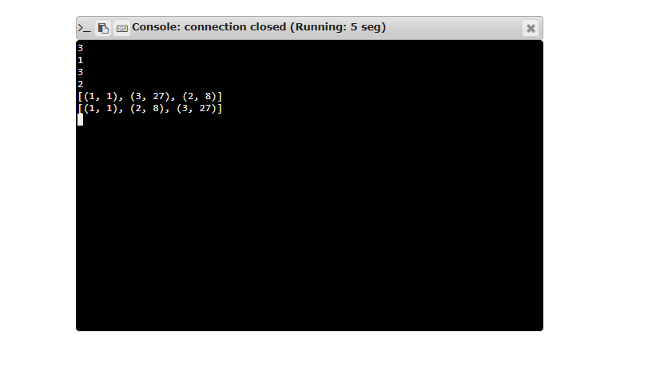

RESULT:

The output of the program is verified successfully.